CURRICULUM VITAE 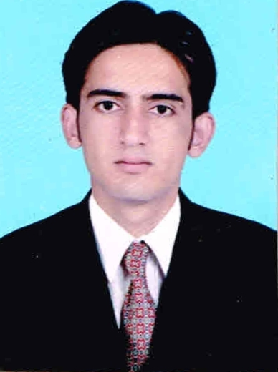

Present Mailing Address :
Pawan Kumar
V.P.O – Migni Khera
Tehsil - Hisar
Dist. Hisar-125052 (Haryana)
Contact No. : 08059566333
E-mail Id : pawanmba75@gmail.com

Pawan Kumar

PERSONAL DETAILS
Name : Pawan Kumar
Father’s Name : Sh. Shyam Lal
Date of Birth : Feb. 16th, 1992
Sex : Male
Marital status : Unmarried
Languages known : English & Hindi
E-mail Id : pawanmba75@gmail.com

Career objective

- To secure a good position in the organization where I can utilize my Knowledge & Skills towards the growth of the organization.

Course Details

Course : Master of Business Administration
Specialization : Finance & Marketing

Qualification

Qualification | Subject | University/Board | Percentage | Year of passing
Post-Graduation | M.B.A | GURU JAMBHESHWAR UNIVERSITY HISAR | 57.9% | 2014
Graduation | B.Com | KURUKSHETRA UNIVERSITY | 58.3% | 2012
12th | COMMERCE | HBSE | 71.2% | 2009
10th | ENG HIN MAT SS SCT SKT | HBSE | 64.8% | 2007

Computer Skills

- Windows ,2000,2007,Window XP
- Office Package-MS Word, MS Excel, MS Power Point
- Internet knowledge
- Basic knowledge of computer hardware

Work Experience

- One Year Work Experience in bancsurance in ICICI Prudential Life Insurance
- Joined As Finacial Service Consultant
- On 1st May 2015 promoted as on Designation Associate Financial Service Manager ( Currently Working )

Summer Internship

- Project Work on Project Income Tax Filing at Investascent Wealth Advisor Pvt. Ltd. Gurgaon

Hobbies

- Travelling , Listening Music,Surfing Internet
Personal Traits

- Self confident, Learning Nature. Innovative , Adaptive

Declaration:

I do hereby declare that what is stated above is true to the best of my information and belief.

Dated :
Place : (pAWAN KUMAR)

